New bugs to correct for taboo

1

When I go to edit an existing appointment of a merchant,

A description...

and I click on update appointment

A description...

I get this error message (shown below)

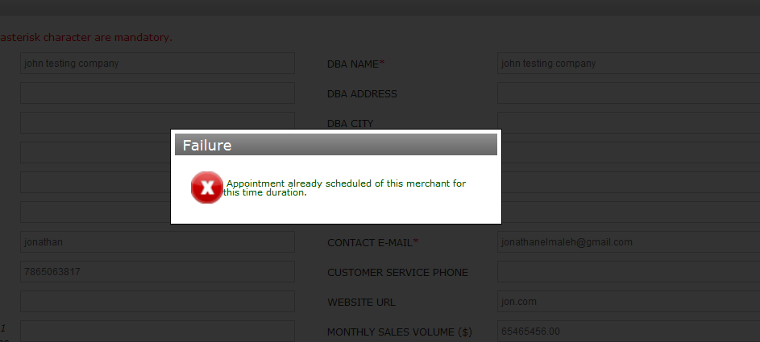

Running Well. It show this failure message only when the appoinment time you want to set is already taken by the same merchant or any other merchant.

2

I got this error when I tried to add an appointment

<http://total-apps.net/superadmin/appointments/addappointment>

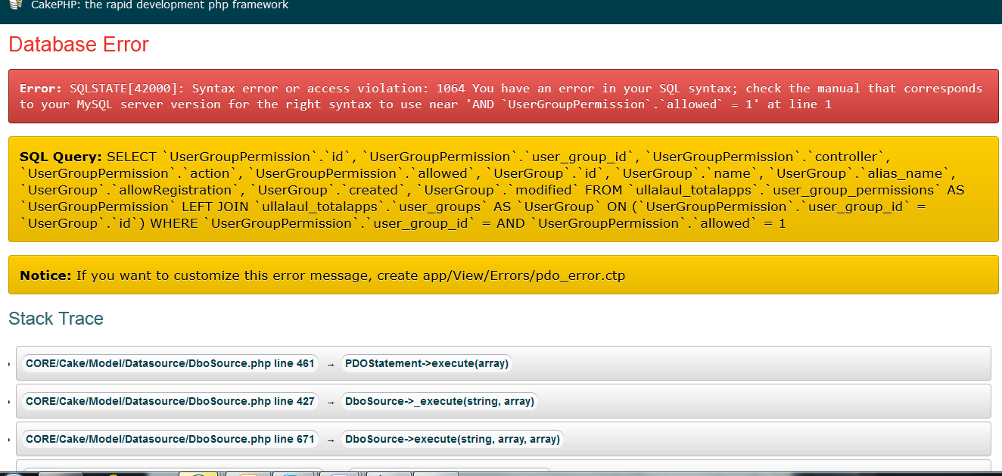

3

When I go and click to edit a merchants info, and I click on the “Rates” tab

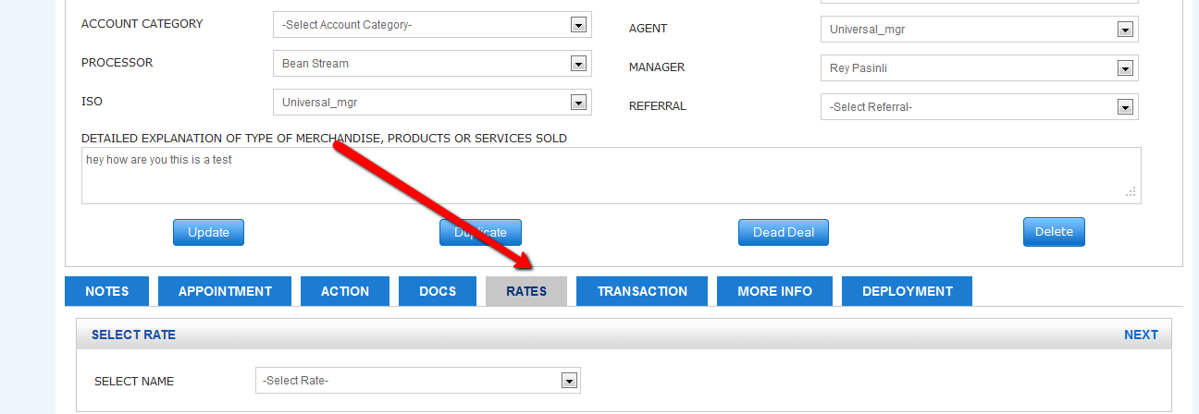

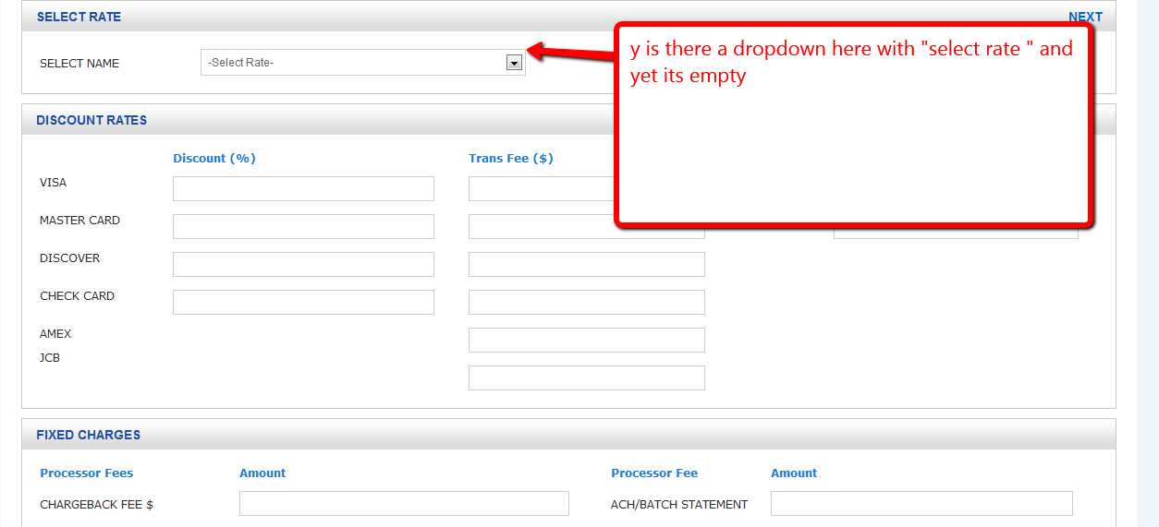

4 Change Timezone to PST(Pacific Standard Time)

Change time zone for the notes time stamp

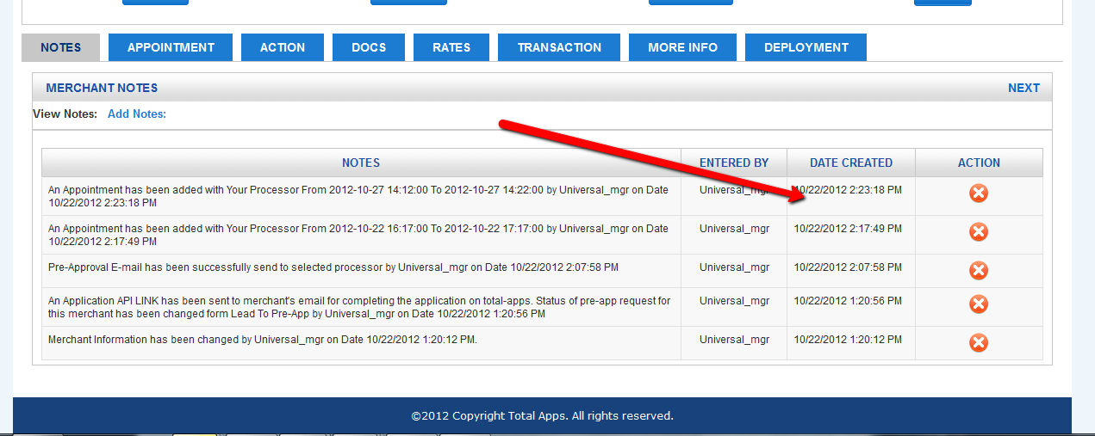

The current time zone is eastern time and it should be pacific time instead.

5 - Resolved

Customer got this error. Please verify that it works properly and test

got this error when trying to send incomplete doc email on account: another test llc

[**Notice** (8)](javascript:void(0);): Constant SITE_URL already defined [**APP/Plugin/Usermgmt/Config/bootstrap.php**, line **36**]

[**Notice** (8)](javascript:void(0);): Constant siteRegistration already defined [**APP/Plugin/Usermgmt/Config/bootstrap.php**, line **42**]

[**Notice** (8)](javascript:void(0);): Constant sendRegistrationMail already defined [**APP/Plugin/Usermgmt/Config/bootstrap.php**, line **47**]

[**Notice** (8)](javascript:void(0);): Constant emailVerification already defined [**APP/Plugin/Usermgmt/Config/bootstrap.php**, line **53**]

[**Notice** (8)](javascript:void(0);): Constant emailFromAddress already defined [**APP/Plugin/Usermgmt/Config/bootstrap.php**, line **59**]

[**Notice** (8)](javascript:void(0);): Constant emailFromName already defined [**APP/Plugin/Usermgmt/Config/bootstrap.php**, line **64**]

[**Notice** (8)](javascript:void(0);): Constant loginRedirectUrl already defined [**APP/Plugin/Usermgmt/Config/bootstrap.php**, line **69**]

[**Notice** (8)](javascript:void(0);): Constant logoutRedirectUrl already defined [**APP/Plugin/Usermgmt/Config/bootstrap.php**, line **74**]

[**Notice** (8)](javascript:void(0);): Constant PERMISSIONS already defined [**APP/Plugin/Usermgmt/Config/bootstrap.php**, line **79**]

[**Notice** (8)](javascript:void(0);): Constant ADMIN_PERMISSIONS already defined [**APP/Plugin/Usermgmt/Config/bootstrap.php**, line **84**]

[**Notice** (8)](javascript:void(0);): Constant defaultGroupId already defined [**APP/Plugin/Usermgmt/Config/bootstrap.php**, line **89**]

[**Notice** (8)](javascript:void(0);): Constant ADMIN_GROUP_ID already defined [**APP/Plugin/Usermgmt/Config/bootstrap.php**, line **94**]

[**Notice** (8)](javascript:void(0);): Constant GUEST_GROUP_ID already defined [**APP/Plugin/Usermgmt/Config/bootstrap.php**, line **99**]

6

Customer got this error also - Resolved

When I tried to hit “Next” after filling out the test link: <http://total-apps.net/superadmin/apis/merchantbasicinfo/2824>

I get this:

| **Nr** | **Query** | **Error** | **Affected** | **Num. rows** | **Took (ms)** |
| --- | --- | --- | --- | --- | --- |
| 1 | SELECT `Merchant`.`id`, `Merchant`.`CID`, `Merchant`.`merchantFileNumber`, `Merchant`.`merchantName`, `Merchant`.`legalAddress`, `Merchant`.`legalCity`, `Merchant`.`legalState`, `Merchant`.`legalCountry`, `Merchant`.`legalZip`, `Merchant`.`merchantDBA`, `Merchant`.`dbaAddress`, `Merchant`.`dbaCity`, `Merchant`.`dbaState`, `Merchant`.`dbaCountry`, `Merchant`.`dbaZip`, `Merchant`.`businessFax`, `Merchant`.`customerServicePhone`, `Merchant`.`merchantURL`, `Merchant`.`sicMCC`, `Merchant`.`federalName`, `Merchant`.`federalTaxId`, `Merchant`.`detailExplanation`, `Merchant`.`merchantType`, `Merchant`.`startDate`, `Merchant`.`sendUpDate`, `Merchant`.`integrationDate`, `Merchant`.`preappDate`, `Merchant`.`pendingDate`, `Merchant`.`processingDate`, `Merchant`.`approvalDate`, `Merchant`.`incompleteDate`, `Merchant`.`setupfeePaidDate`, `Merchant`.`contactPhone`, `Merchant`.`contactEmail`, `Merchant`.`contactName`, `Merchant`.`statusID`, `Merchant`.`accountTypeID`, `Merchant`.`accountCategory`, `Merchant`.`agentID`, `Merchant`.`processorID`, `Merchant`.`gatewayID`, `Merchant`.`managerID`, `Merchant`.`isoID`, `Merchant`.`referalID`, `Merchant`.`acceptCreditCard`, `Merchant`.`terminatedCreditCard`, `Merchant`.`terminatedDate`, `Merchant`.`processBefore`, `Merchant`.`processorAndLeaveReason`, `Merchant`.`hasBankruptcy`, `Merchant`.`hasRefundPolicy`, `Merchant`.`describePolicy`, `Merchant`.`hasThirdParty`, `Merchant`.`softwareUsed`, `Merchant`.`hasSeasonal`, `Merchant`.`monthNames`, `Merchant`.`b2bOfTotalsale`, `Merchant`.`b2bOfbankcard`, `Merchant`.`b2cOfTotalsale`, `Merchant`.`tradeName`, `Merchant`.`advertiseMethod`, `Merchant`.`depositeTimeFrame`, `Merchant`.`tradeContactName`, `Merchant`.`bankName`, `Merchant`.`bankPhone`, `Merchant`.`bankContactName`, `Merchant`.`depositRquired`, `Merchant`.`tradePhone`, `Merchant`.`bankContact`, `Merchant`.`transitNumber`, `Merchant`.`telephone`, `Merchant`.`accountNumber`, `Merchant`.`vendorDetail`, `Merchant`.`deliveryTimeFrame2`, `Merchant`.`deliveryTimeFrame1`, `Merchant`.`b2cOfbankcard`, `Merchant`.`leaveDeposited`, `Merchant`.`deliveryTimeFrame3`, `Merchant`.`productFullfillmentBy`, `Merchant`.`deliveryTimeFrame4`, `Merchant`.`ccDepositedOther`, `Merchant`.`ccDeposited`, `Merchant`.`midID`, `Merchant`.`underW`, `Merchant`.`completed`, `Merchant`.`orderMachine`, `Merchant`.`setUpFeePaid`, `Merchant`.`chargeBackRatio`, `Merchant`.`setupFee`, `Merchant`.`agentSetupFee`, `Merchant`.`managerSetUpFee`, `Merchant`.`isoFee`, `Merchant`.`isoCommision`, `Merchant`.`discountRate`, `Merchant`.`OMRate`, `Merchant`.`agentPayout`, `Merchant`.`volume`, `Merchant`.`agentSplit`, `Merchant`.`incorporation`, `Merchant`.`procUID`, `Merchant`.`procPWD`, `Merchant`.`descriptor`, `Merchant`.`accessFee`, `Merchant`.`bankReserve`, `Merchant`.`transFee`, `Merchant`.`procCycle`, `Merchant`.`creditPerItemCharge`, `Merchant`.`chargeBackPerItemFee`, `Merchant`.`isoSplit`, `Merchant`.`upSplit`, `Merchant`.`merchantSign`, `Agent`.`user_Name`, `Agent`.`userEmail`, `Processor`.`user_Name`, `Processor`.`userEmail`, `Processor`.`processorPackage`, `Processor`.`processorPackageFilename`, `Processor`.`email_template`, `Manager`.`user_Name`, `Manager`.`userEmail`, `Manager`.`userPhone`, `Manager`.`userCompany`, `Manager`.`userCompanyUrl`, `ISO`.`user_Name`, `ISO`.`userEmail`, `Referal`.`user_Name`, `Referal`.`userEmail` FROM `ullalaul_totalapps`.`merchants` AS `Merchant` LEFT JOIN `ullalaul_totalapps`.`users` AS `Agent` ON (`Merchant`.`agentID` = `Agent`.`id`) LEFT JOIN `ullalaul_totalapps`.`users` AS `Processor` ON (`Merchant`.`processorID` = `Processor`.`id`) LEFT JOIN `ullalaul_totalapps`.`users` AS `Manager` ON (`Merchant`.`managerID` = `Manager`.`id`) LEFT JOIN `ullalaul_totalapps`.`users` AS `ISO` ON (`Merchant`.`isoID` = `ISO`.`id`) LEFT JOIN `ullalaul_totalapps`.`users` AS `Referal` ON (`Merchant`.`referalID` = `Referal`.`id`) WHERE `Merchant`.`id` = 2824 LIMIT 1 |  | 1 | 1 | 2 |

7 - Resolved

Please take off the debug mode and make sure that when a user receives and email with the link to fillout the form that there are no error being displayed and that all the fields are mapped correctly.

Message sent from customer

Our system was originally designed to enable our merchants to fill out our application online. We need to start testing this to make sure all the fields are mapping correctly and the final PDF copy is correct. Please verify that this works correctly

What is the URL we need use for our online applications with MeritCard?

What is a merit card?